Submitted by: Darshan S

**SHOPNEST STORE CAPSTONE PROJECT**

**Question Statement:**

Identify the rating distribution in the Shop Nest dataset, showcasing ratings categorized as Excellent, Very Good, Good, Bad, and Very Bad, along with corresponding orders.

**Visualization:**

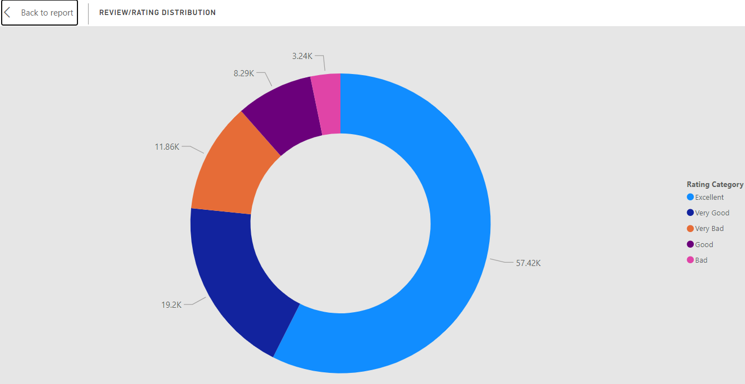

**Explanation:**

The donut chart represents the rating distribution across all the orders placed, which provides insights on overall satisfaction among customers regarding the orders.

Among the rating categories, majority of the ratings fall under the "Excellent" category which is 5-rating, accounting for 57,420 reviews. This is followed by the "Very Good" category which is 4-rating with 19,200 reviews. The "Bad" which is a 2-rating and "Good" categories which is a 3-rating have 3,235 and 8,287 ratings, respectively, while the "Very Bad" category has the fewest ratings at 11,858.

Noticeably, the highest number of 5-ratings (“Excellent” category) have come in the month of August and the reason for that probably is due to the high number of orders successfully delivered on-time which has increased the customer-satisfaction, in-turn giving us good reviews from the customers.

The data highlights a significant skew towards positive feedback, with the "Excellent" and "Very Good" categories making up the majority of the ratings, while negative feedback ("Very Bad" and "Bad") is less prevalent. This suggests a generally positive customer experience.

**Question Statement:**

What are the top 10 and bottom 18 most popular product categories in the Shop Nest dataset? Please list them based on the number of orders.

**Visualization:**

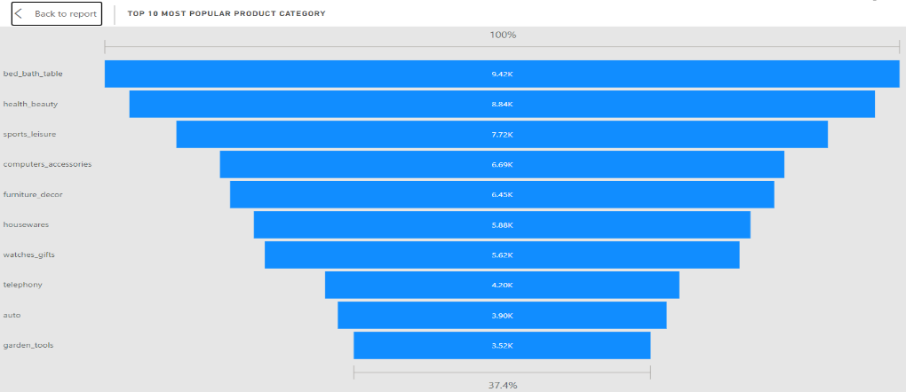

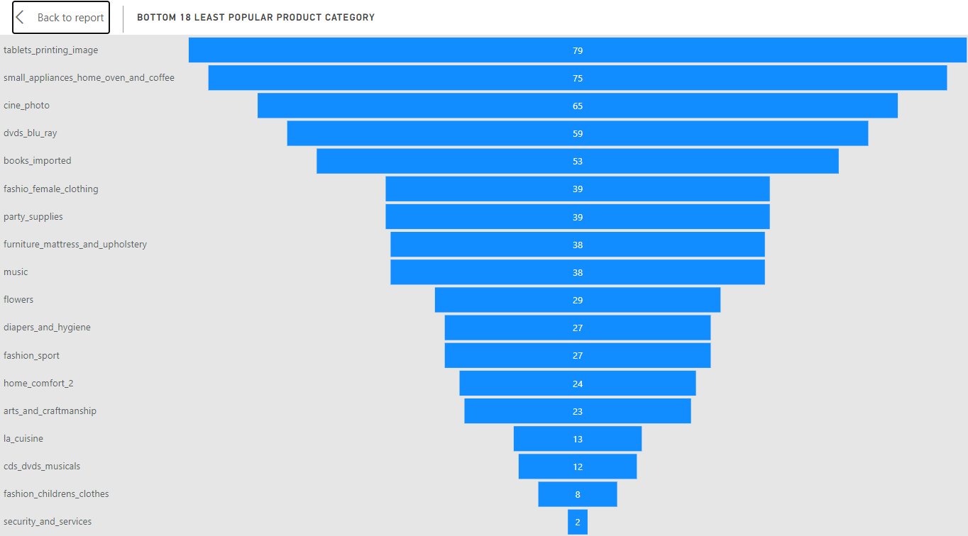

**Explanation:**

The funnel chart presents an overview of the top 10 most popular and 18 least popular product categories in terms of number of orders placed for these items.

The data reveals "bed_bath_table" leads with 9,417 orders, followed closely by "health_beauty" with 8,836 orders. Other prominent categories include "sports_leisure" with 7,720 orders, "computers_accessories" with 6,689 orders and “furniture_decor” with 6449 orders. These categories represent bulk of customer interest, indicating strong consumer demand in these categories.

On the other hand, the bottom 18 least popular product categories show a significant drop in interactions. "tablets_printing_image" has only 79 orders, followed by "small_appliances_home_oven_and_coffee" with 75 orders, and "cine_photo" with 65 orders. At the very bottom are "security_and_services" with just 2 orders, "fashion_childrens_clothes" with 8 orders and cds_dvds_musicals with only 12 orders.

This stark contrast between the most and least popular categories highlights specific areas of strong demand versus those with minimal customer engagement.

**Question Statement:**

List the total number of active sellers by yearly and monthly.

**Visualization:**

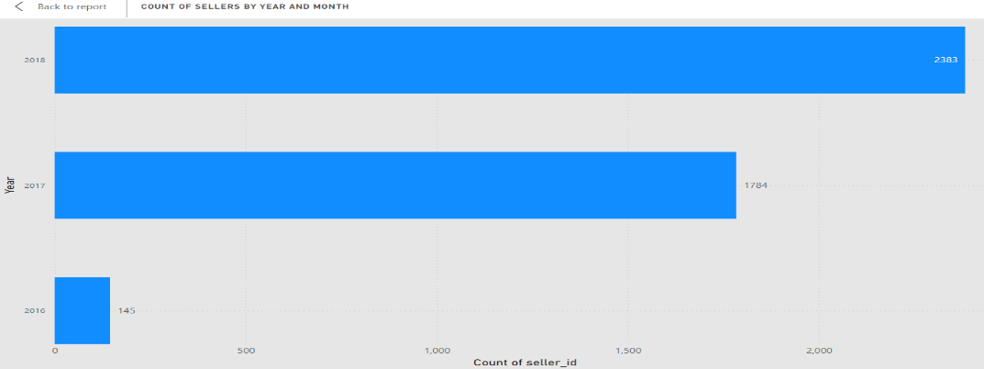

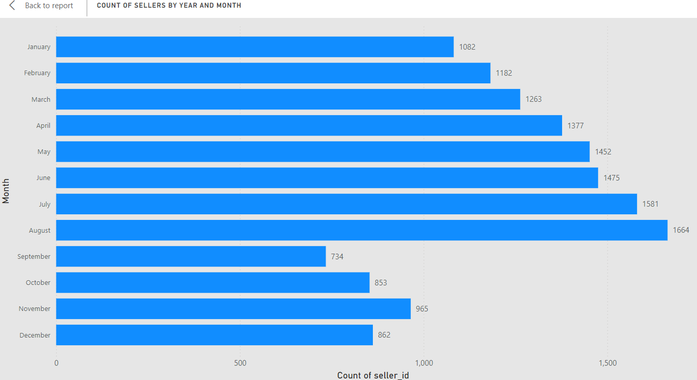

**Explanation:**

The bar chart depicts the count of active sellers available for each month and then to the corresponding year in total.

The "Count of Sellers by Year" chart illustrates a significant growth in the number of sellers over time. Starting with just 145 sellers in 2016, the number dramatically increased to 1,784 in 2017, and then to 2,383 in 2018. This upward trend indicates a robust expansion in the seller base, likely due to factors such as market penetration, increased platform adoption, or enhanced seller support.

In the "Count of Sellers by Month" chart, the data reveals that seller activity peaks mid-year, particularly in August (1,664 sellers) and July (1,581 sellers). The first half of the year shows a steady rise in seller count, with January starting at 1,082 sellers and climbing month by month. However, there's a notable decline as the year progresses, with September (734 sellers) and October (853 sellers) experiencing a drop in seller count, possibly due to seasonal influences or other market factors.

**Question Statement:**

Which payment methods are most commonly used by Shop Nest customers.

**Visualization:**

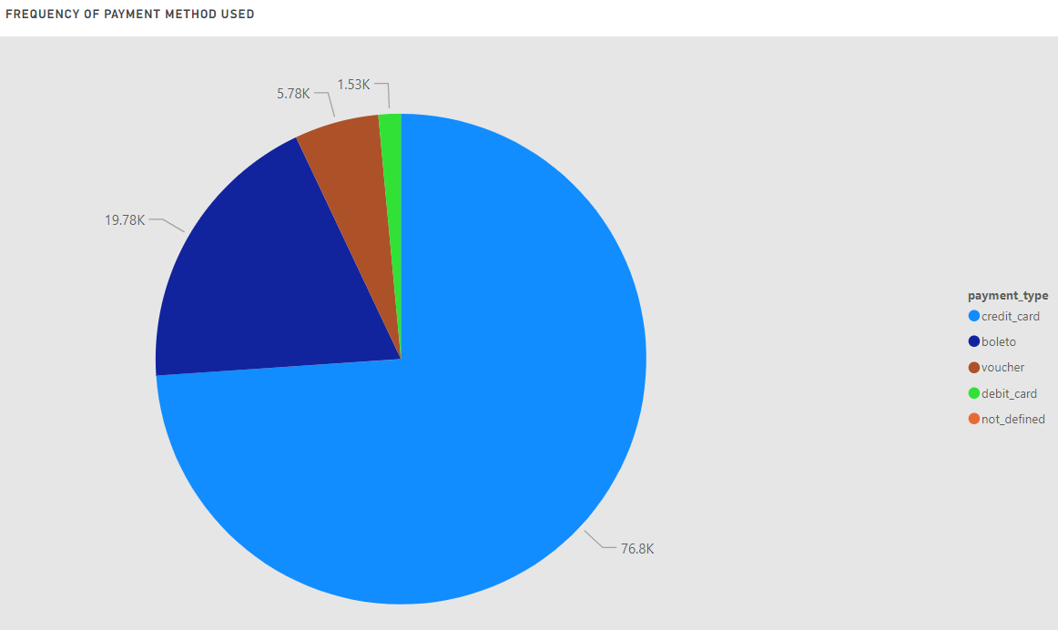

**Explanation:**

The pie chart displays the payment methods used to place orders across all the orders placed, providing key insights into transaction preferences.

Credit card emerges as the most popular mode of payment with 76795 times out of all the orders, which is approximately 73.9% of all the orders. The second most popular mode of payment being Boleto with it being used for 19,784 orders which is about 19% of total orders, closely followed by Vouchers being used for 5,755 orders, constituting for 5.6% of all the orders. Debit cards are also used as payment mode for about 2k orders which shares 1.5% of total orders.

The visualization highlights the dominance of credit card payments, suggesting a preference for convenience and flexibility among customers. Also, the pie chart underscores the importance of offering diverse payment options to cater to varying customer preferences and needs.

The presence of boleto, voucher, and debit card payments indicates significance of providing alternative payment channels to accommodate different customer demographics and preferences.

**Question Statement:**

Identify the product category wise profit margin

**Visualization:**

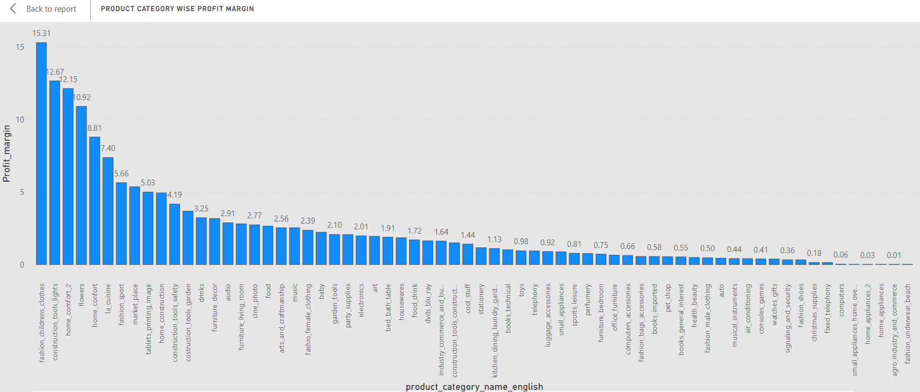

**Explanation:**

The column chart presents an overview of profit margin across all product categories, ranking the product categories on their profitability to the company.

The highest profit margin is seen in the "fashion_childrens_clothes" category, with a margin of 15.31%, followed by "construction_tools_lights" at 12.67%, and "home_comfort_2" at 12.15%. These categories represent the most profitable segments along with “flowers” at 10.92% and “home_comfort” at 8.81% constituting the top 5 most profitable product categories.

On the other end of the spectrum, categories such as "fixed_telephony," "computers," and "small_appliances_home_oven" have the lowest profit margins, barely reaching 0.17%, 0.06%, and 0.03% respectively. “agro_industries_and_commerce” also have a low profit margin of 0.01%. The other categories which have almost zero-profit margin are “fashion_underwear_beach”, ”cds_dvds_musicals, ”construction_tools”, ”security_and_services”, “diapers_and_hygiene” and “furniture_mattress_and_uphoistery”.

The data suggests that while certain categories yield high profitability, others contribute very little to overall margins, indicating potential areas for strategic improvement or re-evaluation.

**Question Statement:**

Determine the monthly payments made by customers using credit cards.

**Visualization:**

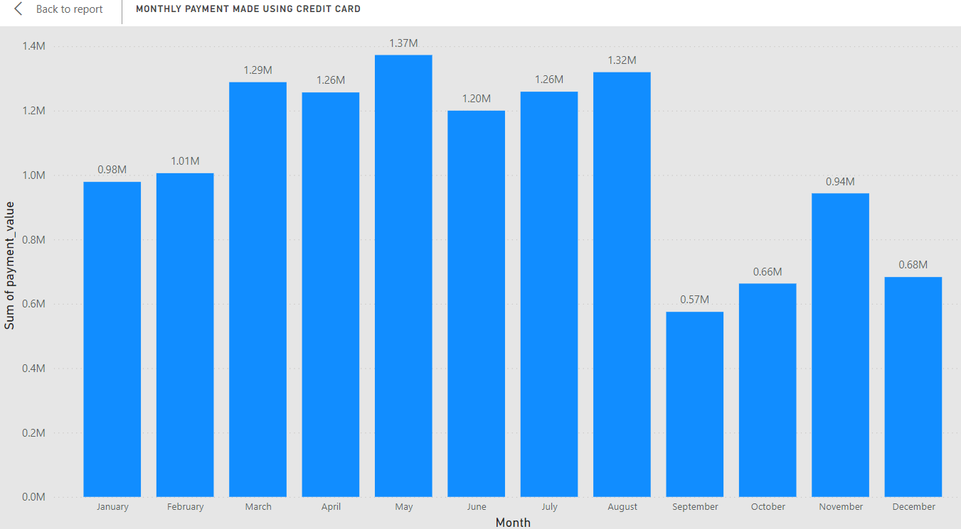

**Explanation:**

The column chart illustrates the credit card payments made over the years divided across months, revealing significant fluctuations in spending.

The highest payment amount occurred in May, reaching 1.37 million, suggesting a peak in credit card usage during this month. Other notable months include March, April, July and August, each exceeding 1.2 million in payments, indicating periods of increased spending specifically, 1.29 million, 1.26 million, 1.26 million and 1.32 million respectively.

On the other hand, September experienced the lowest payment value at 0.57 million, marking a dip in credit card transactions. While the first quarter of the year showed consistent increase in spending, December's payment value of 0.68 million was surprisingly low, possibly indicating lower-than-expected spending. The dip seems to have begun at the end of 3rd quarter due to which majority of 4th quarter was a recovery from the dip. Unfortunately, the 4th quarter also ended with a dip in credit card spendings on December, just like the previous quarter.

Overall, the data highlights varying patterns of credit card usage, with 2nd Quarter (April, May and June) having the highest credit card transactions and 4th quarter (October, November, December) being the time period with least number of transactions.

**Question Statement:**

Identify sellers categorized by city, excluding cities starting with the letters S and B.

**Visualization:**

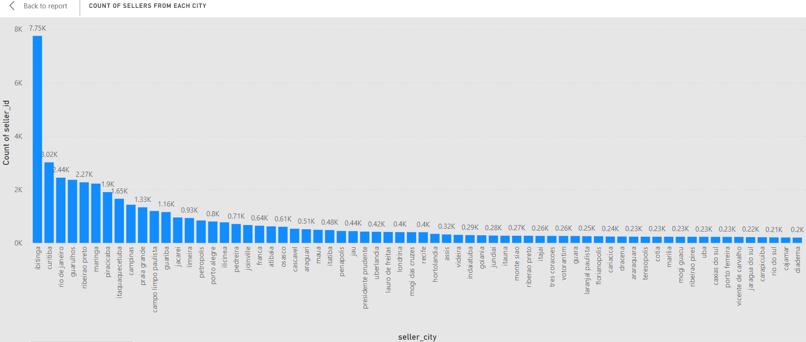

**Explanation:**

The column chart presents an overview of sellers available across all the cities in the country, ranking the cities according to the number of active sellers available.

The city with the highest number of available sellers turns out to be Ibitinga with a total of 7750 sellers. The following city with the second most available sellers is Curitiba with 3016 sellers, followed by Rio De Janeiro at third with 2442 sellers. Guarulhos and Ribeirao Preto also have high number of active sellers with 2362 and 2269 sellers respectively.

A noticeable drop-off occurs after the top few cities. For example, the seventh-ranked city, Piracicaba, has around 1.9K sellers, which is significantly lower than the leading cities. The majority of the cities listed have seller counts ranging from about 200 to 800, indicating a broad distribution of sellers across many smaller cities.

The chart displays a long tail distribution, where a few cities have a large number of sellers, while the majority have relatively few. This visualization helps identify which cities contribute the most to the seller base, with Ibitinga standing out as a major hub. Noticeably, most of the active sellers are found in the southern part of Brazil as compared to the northern part of the country.

**Question Statement:**

Create a dynamic visual that compares the number of delayed orders to the number of orders received earlier for each month. Utilize the drill through the cross-report feature to provide a detailed analysis of late and on-time deliveries.

**Visualization:**

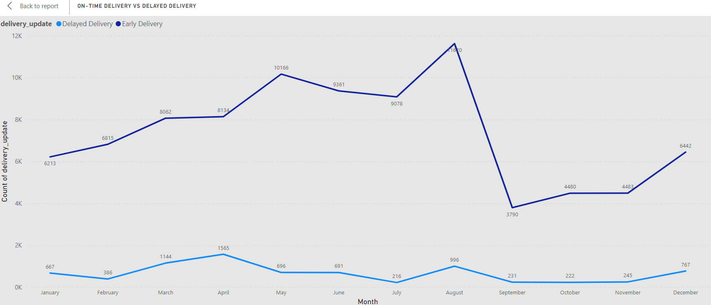

**Explanation:**

The line chart represents count of orders delivered on time versus orders that were delayed across all months giving us an insight into order fulfilment performance across the year.

According to the data, August emerges as the month with the largest disparity between delayed and on-time delivered orders, with 11,620 orders delivered on-time compared to a only 996 delayed orders, showcasing exceptional efficiency in meeting customer demands. Notably, August is also the month where we have received the highest 5-rating reviews and a big contribution to that has to be the high number of on-time deliveries.

Alternatively, September records the smallest gap between delayed and earlier orders, with 3,790 orders delivered on-time and 231 delayed orders. The month September also shows a sudden dip of almost 65% in the number of on-time delivered orders. The graph gradually sees a consistent rise of on-time delivered orders in the month of October, November and December with 4,480, 4,483 and 6,442 on-time delivered orders respectively and delayed orders accounting to 222, 245 and 767 orders respectively. The consistent increase in both on-time delivered orders and delayed orders goes through from January until the month of August.

Using these findings, the organization can address operational shortcomings, optimize resource allocation, and implement targeted strategies to cut-down delays, thereby enhancing customer satisfaction and loyalty